**TEST Document : WPIGLOWDSD-27150**

**Case:** We have a DRAFT-00019-24-0002463 that will not print in Workday with an error message received of ‘Failed’

Root cause of issue is , that in current design it puls all the invoice for processing even its cancelled . In case of DRAFT-00019-24-0002463 first invoice was in USD which was cancelled and another was in EURO. So summing up both different currency value have caused the issue

RD: CR Customer Invoice Printing Report - Report Design

Calc field: Changes to Cal field  CF AC All Rest Related Custom Invoices - Sum Amount Due  > CF SRI All related Invoice Amount >CF LRV All Project Related Customer Invoice Documents(On CINV Document) >CF ARI Project All Related Customer Invoice Documents(All Projects)  added Condition CF Invoice Status Not Canceled  NOT to pick up transaction whos Invoice Document Status is cancelled

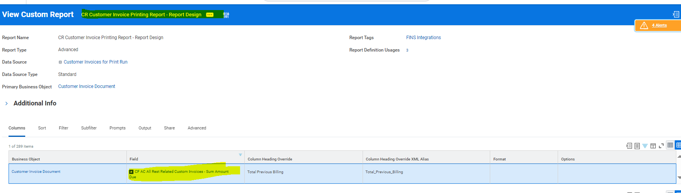

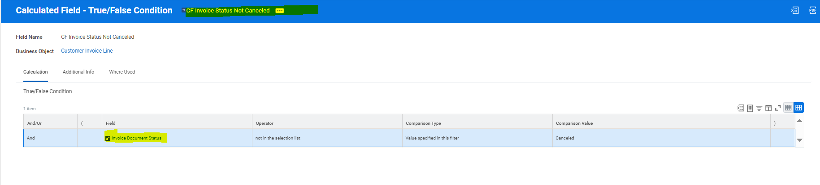

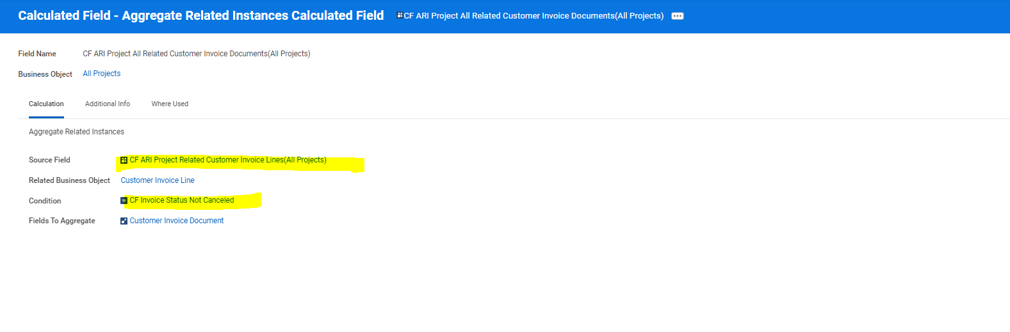

**Migration Plan :**

* Add new cal field : CF Invoice Status Not Canceled
* Manually change the calf field CF ARI Project All Related Customer Invoice Documents(All Projects)

**Roll Back Plan :**

* Remove CF Invoice Status Not Canceled condition from calf field CF ARI Project All Related Customer Invoice Documents(All Projects)

|  |  |  |
| --- | --- | --- |
| * | **Task** | **Action Taken** |
| **1** | Add details of changes to CR | We have a DRAFT-00019-24-0002463 that will not print in Workday with an error message received of ‘Failed’  Root cause of issue is , that in current design it puls all the invoice for processing even its cancelled . In case of DRAFT-00019-24-0002463 first invoice was in USD which was cancelled and another was in EURO. So summing up both different currency value have caused the issue |
| **2** | Update design documentation & attach if needed | Updated in Confluence https://confluence.uhub.biz/pages/viewpage.action?pageId=422381139 |
| **3** | Attach evidence of unit testing | Yes , Attached in https://jira.uhub.biz/projects/WPIGLOWDSD/queues/issue/WPIGLOWDSD-26805 |
| **4** | Attach business approval to put this change live | Yes Attached in https://jira.uhub.biz/projects/WPIGLOWDSD/queues/issue/WPIGLOWDSD-26805 |
| **5** | Peer Review completed ? | Yes , Athul |
| **6** | Manager Approval Received ? | Yes |
| **7** | Detail Migration Steps to be made | Added to Added to WPIGLOWDSD-27150 |
| **8** | Rollback Plan | Added to Added to WPIGLOWDSD-27150 |
| **9** | Update Confluence - WPP | Yes |
| **10** | Inform the Program if integration is in future waves | Yes |